Christmas Don’t Be Late/The Chipmunk Song v9
Ross Bagdasarian Sr. 1958

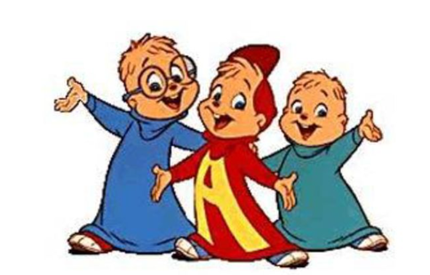
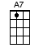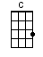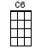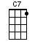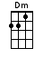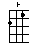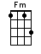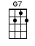
SLOW/Waltz-D dudu

Intro: [C] [F] [C] [C]

[C] Christmas, [C6] Christmas [G7] time is [G7] near
[G7] Time for [G7] toys and [C6] time for [C6] cheer
[Dm] We’ve been [G7] good, but [Dm] we can’t [G7] last
[Dm] Hurry, [G7] Christmas! [C] Hurry [C6] fast!

[C] Want a [C6] plane that [C] loops the [C6] loop
[C7] Me, I [C7] want a [F] hula [F] hoop
[F] We can [Fm] hardly [C] stand the [A7] wait
Please [Dm] Christmas, [G7] don’t be [C] late [C]

[C] Christmas, [C6] Christmas [G7] time is [G7] near
[G7] Time for [G7] toys and [C6] time for [C6] cheer
[Dm] We’ve been [G7] good, but [Dm] we can’t [G7] last
[Dm] Hurry, [G7] Christmas! [C] Hurry [C6] fast!

[C] Want a [C6] plane that [C] loops the [C6] loop
[C7] Me, I [C7] want a [F] hula [F] hoop
[F] We can [Fm] hardly [C] stand the [A7] wait
Please [Dm] Christmas, [G7] don’t be [C] late [C]
[F] We can [Fm] hardly [C] stand the [A7] wait
Please [Dm] Christmas, [G7] don’t be [C] late [C↓]

